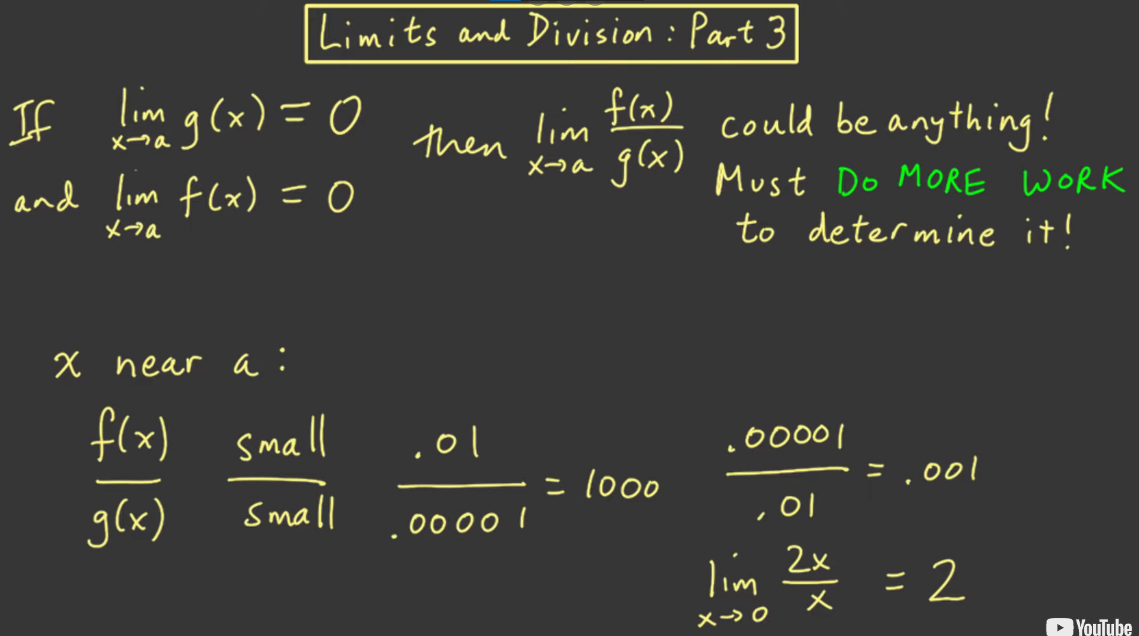

* It indicates how small are the two limits relative to each other
  + Eg: in the lim 2x/x as x->0
    - The numerator is always twice the denominator so the limit is 2